KUBERNETES TASK – 05  
=======================

1) Create a namespace dev-environment and apply a resource-based quota that restricts the number of pods to 3 and services to 2.

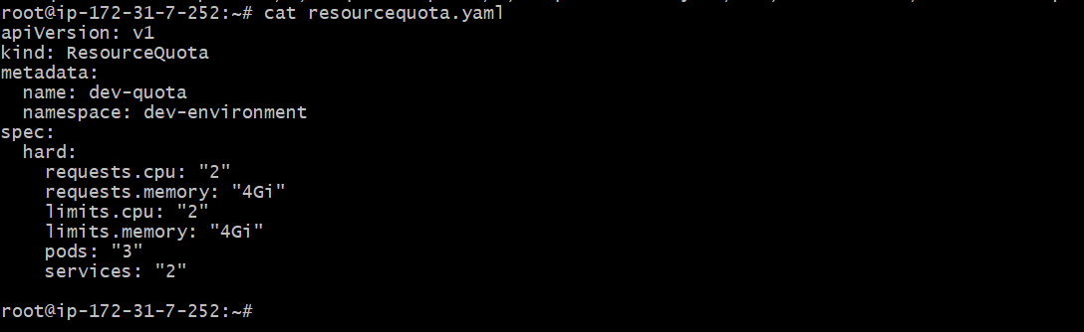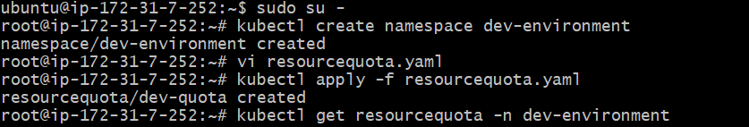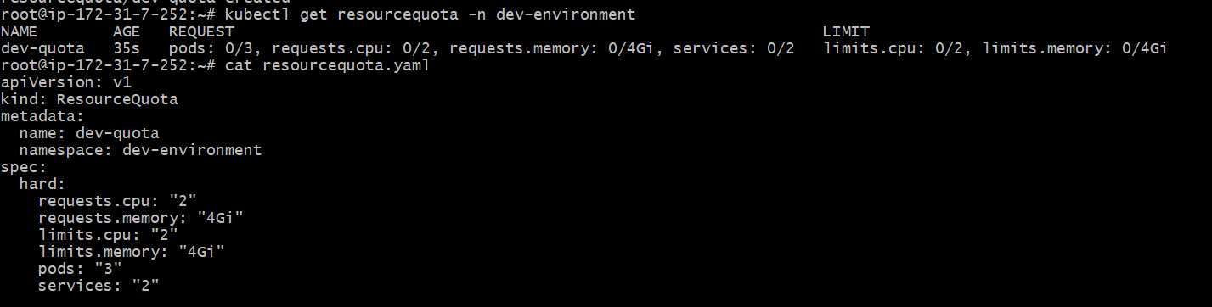

2)Create a pod in the prod-environment namespace with 0.2 CPU and 200Mi memory requests, and 0.5 CPU and 500Mi memory limits.

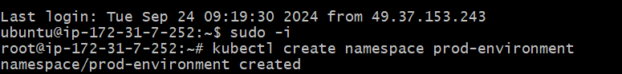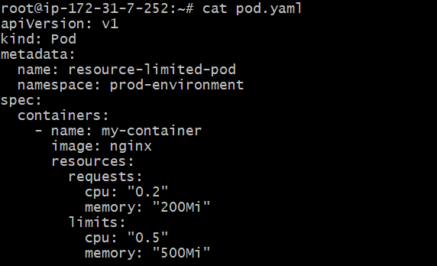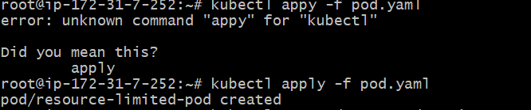

3)In the staging-environment namespace, set a LimitRange that assigns default CPU and memory limits (300m CPU, 600Mi memory) and applies a minimum and maximum CPU.

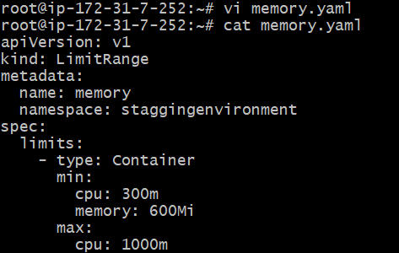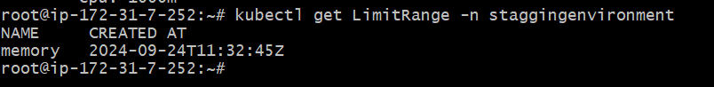

4) Create a pod and a NodePort service in the default namespace, then create another pod in the test namespace and communicate between them using Service DNS.

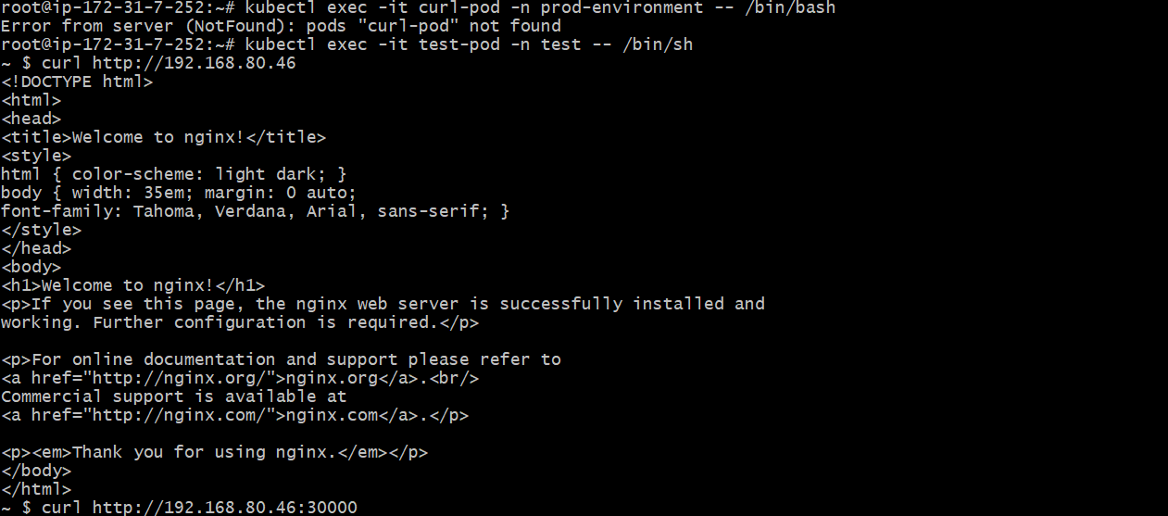

5) Apply a LimitRange with a max limit/request ratio of 2 for memory in the performance-environment namespace, and test by creating a pod with mismatched resource requests and limits.

